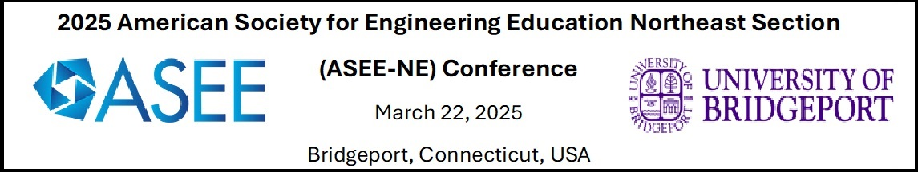

CALL FOR POSTERS

The 2025 ASEE-NE Conference invites undergraduate and graduate students to submit a poster to the Student Projects Posters Competition. Posters will be presented by students and judged during the Conference on Saturday, March 22, 2025, starting at 10:00 am. The poster awards will be announced at the Conference banquet on Saturday, March 22, 2025, at 6 PM. The ASEE, the University of Bridgeport and industry partners will sponsor several monetary awards for the highest ranking, presented posters.

Important Dates

- January 24, 2025: Poster abstract submission deadline
- February 14, 2025: Notification of poster acceptance
- March 15, 2025: Early bird registration ends
- March 22, 2025: Poster presentation

Poster Submissions
Students are encouraged to present their on-going or finished projects. A poster abstract will be submitted in advance and reviewed by the Posters Technical Committee. A template for abstract is available here and here. Accepted posters for the undergraduate and graduate competitions should be a maximum of 36 inches tall by 48 inches wide. They should be mounted on cardboard/ foam core, as your poster must be free standing. Due to space restrictions, tables, power supply, and audio-visual equipment will not be available for poster presentations. Chairs are provided only for those with special accommodation needs.

All posters must be submitted through the Conference Online Poster Submission System. Please click here to submit your poster abstract.

The purpose of the Graduate and Undergraduate Poster Competitions is to provide students with the opportunity to present their work in a professional setting. It is the responsibility of the student presenters to create a poster that effectively communicates the goals, objectives, methods, and results of their work, be it research, community service, or a Capstone design project. Students can submit abstracts for the poster competitions at the conference website.
The poster competition sessions (both undergraduate and graduate) are scheduled from 10:00am to 12pm on Saturday, March 22, 2025 in the Social Room in the John J. Cox Student Center on the University of Bridgeport. Each registered student poster will check-in at the registration desk in the Social room entrance, where they will be assigned an easel to set up their poster. After setup, the students must wait by their poster until they are judged by a minimum of three (3) judges. Once a student poster has been displayed and judged, students will have the opportunity to attend the faculty and/or student presentations. Student poster and paper competition winners will be announced at the Conference dinner on Saturday, March 22.
Posters for the undergraduate and graduate competitions should be a maximum of 36 inches tall by 48 inches wide. They should be mounted on cardboard/ foam core, as your poster must be free standing. Due to space restrictions, tables, power supply, and audio-visual equipment will not be available for poster presentations. Chairs are provided only for those with special accommodation needs.
As stated previously, posters should effectively communicate the goals, objectives, methods and results of your work. Remember that your audience will almost certainly not be specialists in your area, and many visitors will be students and faculty from other departments. Be prepared to describe your work in a language that a knowledgeable individual with a science/engineering background can understand. Keep equations to a minimum, use graphics to their full advantage, ensure text is large enough to read a few feet away from the poster, and fill up all empty space! Commons sections of successful posters include but are not limited to abstract, objectives, findings, and future work. It may be advantageous to bring copies of your poster abstract to handout to visitors and/or judges that request a copy.
All submission inquiries should be sent by email to the Posters Technical Committee Chair, Dr. Peiqiao Wu.

